
STP300
Stepper Motor Controller
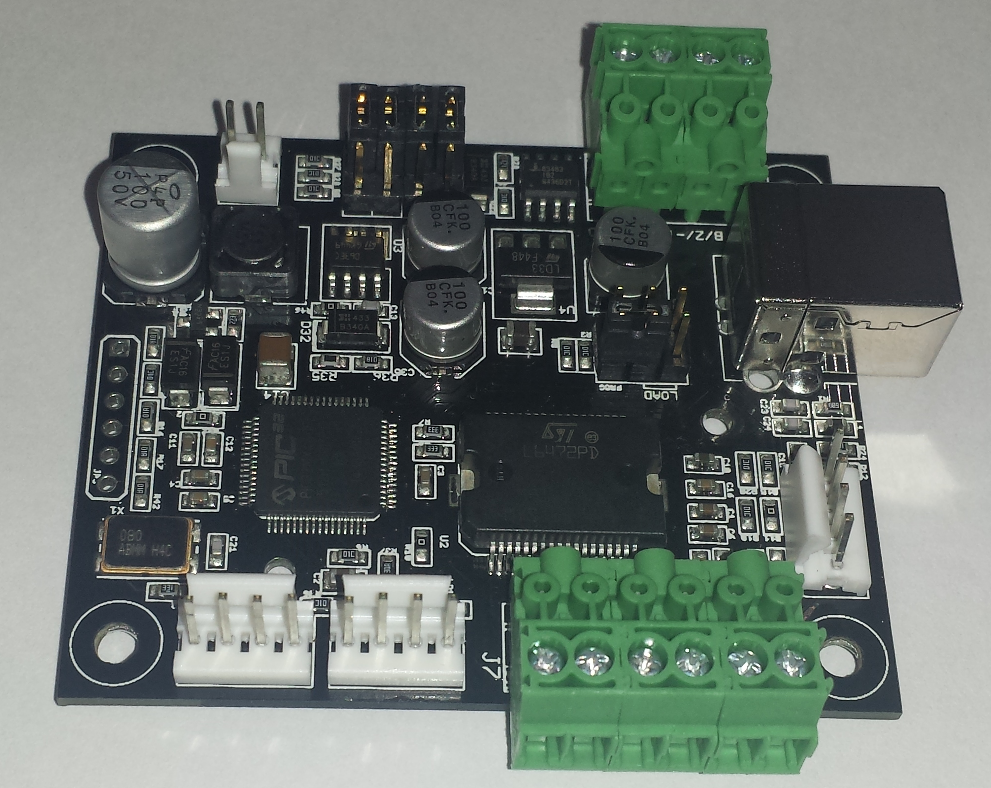
March 3, 2015
www.pontech.com
Preface
This documentation reflects the technical specifications of the ST300 Firmware V1.0.
Table Of Contents
Preface 2
Table Of Contents 3
Introduction to the STP300 5
Stepper Motor Basics 6
Bipolar, Unipolar 6
Motor Construction 6
Bipolar Operation 7
Operating a Unipolar as Bipolar 7
Board Connections 8
STP300 Board Connections: 8
Connecting a host computer to the STP300 board(s) 10
USB(Serial) 10
RS-485 Network 10
Connecting a Stepper Motor to the STP300 11
Connecting power to the STP300 12
Powering the STP300 12

Board Operation 14
The motor current limit 14
Current Limiting on the STP300 14
Command Structure 16
Returned Values 16
Command Examples 17
Command List 18
Board Control Commands 18
BDn Select Board 18
PSn Pin Set 18
PCn Pin Clear 18
RPn Read Pin 19
ADn Read a voltage on the A/D port 19
WRm n Write to Ram 20
RRn Read from Ram 20
WEm n Write to EEPROM 20
REn Read from EEPROM 20
EEPROM Memory Map: 20
WSS Write System Settings to EEPROM 21
Motion Commands 21
MIn Move Immediately to absolute position 21
IIn Increment Immediately relative to destination position 21
OIn Offset Increment Immediately relative to current position 21
RC Read Current motor position 22
RD Read Destination motor position 22
RT Read delTa motor position 22
RX Read Direction Sign 23
HMn Re-home stepper 23
H0 Halt with deceleration(H-Zero) 23
HI Halt Immediately, do not decelerate 23
H+ Advance CW indefinitely 23
H- Advance CCW indefinitely 23
SO Stepper Off when not moving 23
SP Stepper Powered when not moving 23
SH Step Half 24
SF Step Full 24
SW Step Wave 24
TCn Test if pin Clear, on clear execute HI 25
TSn Test if pin Set, on set execute HI 25
TTn Set Test Mode 25
Acceleration and Speed Commands 26
SDn Step Delay 26
RSD Read Step Delay 26
SAn Set Acceleration/Deceleration Factor 27
RSA Read Acceleration/Deceleration Factor 27
SMn Set Minimum Step Delay Factor 27
RSM Read Minimum Step Delay Factor 27
Commands Summary 29
Warranty and Copyrights 30
Warranty 30
Copyright and Trademarks 30
Disclaimer of Liability 30

Introduction to the STP300
New Picture

The STP300 line of motor controllers is the perfect choice for small to medium stepper motor applications where step precession to 22 bits is required. The STP300 is divided into three functional blocks (Embedded Microprocessor, Motor Driver Circuit, and Serial Line Drivers). The embedded microprocessor gives the STP300 the ability to keep track of an absolute motor position. Among other things, the position is a signed 22-bit number. Other features of the STP300 that are microprocessor controlled include:

Human readable command set
Multi board command processing
STP300 Board status queries (Motor Position, Pin Conditions)

The stepping logic for the STP300 is supplied by a SGS Thompson Stepper chip with built in current limiting. The driver chip supplies up to two Amps per stepper motor winding. The STP300 has the ability to use both USB and RS-485 serial lines.

Stepper Motor Basics

Stepper motors are the motors for the digital age. The rotor of a stepper motor moves in discrete increments or steps (hence the name stepper motor). Because of there discrete nature, the control of a stepper motor lends its self nicely to microprocessor technology. The distance of a stepper motor step is given in degrees per step. Some typical values are shown below:

1.8 degrees / step (200 steps / revolution)
7.5 degrees / step (48 steps / revolution)

Bipolar, Unipolar
There are two common winding configurations for stepper motors: bipolar and unipolar. Bipolar motors have two independent windings while unipolar motors have two independent center tapped windings that tend to get connected together at the center tap while in operation.

Motor Construction
Stepper motors consists of two major components: the stator and the rotor. The stator is the stationary portion of the motor and the rotor is the portion of the motor that rotates. The stator consists of electromagnets that are alternately powered to attract permanent magnets on the rotor. When a magnet is pulled toward an electromagnet, motion is induced into the rotor.

Bipolar Operation
Motion is accomplished by alternately powering one winding then the next and then reversing the power supply and repeating the process. There are several different control schemes that are commonly used for bipolar motors: full-stepping, half-stepping, wave stepping and micro-stepping.

Operating a Unipolar as Bipolar
Here are some illustrations on configuring unipolar motors to operate as bipolar motors. Often it is difficult to determine winding configurations by looking at the motor. Refer to the manufacture specifications for exact information. In a six wire unipolar motor, the center taps are not used and in an eight wire unipolar motor, the windings are tie together in pairs. Because the center taps are not used or the two windings are tie together in series, the voltage rating of the motor is now doubled.

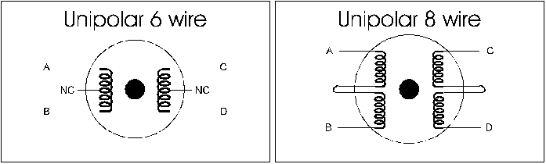
Board Connections

STP300 Board Connections:
The STP300 has eight connectors and six jumpers.
J1
J2
J7

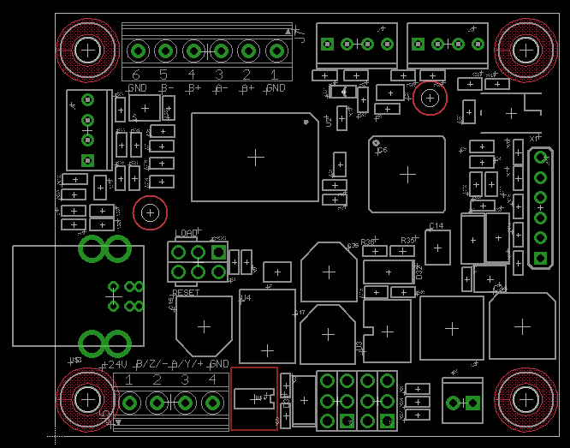
JP3
J6
USB
J5
J4
PROG
J3, J8

Name | Description
J1 | Home Sensor Positive Direction
J2 | Home Sensor Negative Direction
J6 | Extra Motor Stop Sensor
JP3 | Programming Port Microcontroller
J5 | Power in RS485
J4 | 5 Volt Relay Driver
J7 | Motor Connection
USB | USB B socket
PROG | Two Jumpers Load, Reset
J3 | Two Jumpers R485 Terminator, ID+1
J8 | Two Jumpers ID+2, ID+4

Connecting a host computer to the STP300 board(s)
(Connecters: USB)
The STP300 parses input from a USB serial interface and responds with requested information. This allows for easy interface to a host computer with an off the shelf terminal program or custom program.

RS-485 Network
(Connecters: J5)
The STP300 is also equipped a RS-485 interface connector that will allow for multiple boards to be chained together in a network.
The RS-485 connector allow for Half duplex multi drop communication with a host computer.

When using the RS-485 interface, up to 32 devices can be connected to a host computer using only one serial port. A PP232-485f may be needed to convert the RS-485 to RS232.

The RS-485 network setup is suited for applications requiring multiple stepper motors connected to one host computer and longer cable ranges of up to 2000 feet. When using an RS-485 network, termination is required at the end of the network chain. This is done by using the Term. 485 jumper.

Connecting a Stepper Motor to the STP300
(Connectors: J7)
Most bipolar motors come with four wires. They are usually labeled A, B, C and D, where A, B belong to one winding and C, D belong to the other. Connect the wires A to A+, B to A-, C to B+, D to B-, of J7 on the STP300. A+- and B+- may be interchanged if the phase sequence causes the motor to move counter-clockwise when the intended movement is clockwise. If A+ and A- are flipped or if B+ and B- are flipped, the stepper may not operate correctly and cause the motor to oscillate when issued a move command.

Connecting power to the STP300

Powering the STP101
(Connector: J5)
The STP300 is powered by 10-30 volts (24 preferred) applied to the outer pins on the J5 connector the STP300 where labeled.

Board Operation

The motor current limit
To prevent potential damage of your motor. The voltage across each phase should not be above the rating of the stepper motor being used when the motor is not moving. To test the voltage across the winding, connect the stepper motor, serial port and power the STP300. Using an RMS voltmeter set for VDC, place the test leads to terminals A+ and A- of the stepper motor connectors. Current limiting should be adjusted to the maximum current required to prevent the motor from slipping during normal operation. Current limiting on your STP300 is done through Serial commands. If excessive torque is required and the motor can handle greater then two amps per winding, the STP300 may not be capable of driving your motor.

Note: If current limiting is not adjusted properly the stepper motor may operate at excessively high temperature. This can lead to heat damage of the permanent magnets, there by reducing the motor’s torque.

Command Structure
The STP300 processes one ASCII string at a time. The string must be terminated with a carriage return or <ASCII 13>. The board will not process the command string until it encounters the <ASCII 13>. The default communication setting is 115200 baud, N81, with echo off. It will respond to all commands that address it correctly. Any terminal programs such as Procomm, Qmodem or HyperTerminal may be used to test the feature of the STP300 board.

All commands must begin with a "/" followed by the board ID then a space.
/0 V?<enter>
/0 RC<enter>
/0 MI 100<enter>

Multiple commands may NOT be issued on one command string.

Any command or parameter value not in the range of the command will be ignored. The host computer talking to the board should delay a minimum of three milliseconds between each command string sent to give the STP300 time to process the command.

Returned Values
All commands that invoke the STP300 to return a value are formatted as such:

<Number String or String> <ASCII 13>.

Command Examples
Homing the stepper motor
The command below will select board number one, then move the stepper motor until pin the Home switch 2 reads 0 Volts.

/1 H-<enter>
Then use the RT command the see if the motor is still moving. When it hit the limit switch, the motor will stop and the RT command will return “0”. Then home the position to 0 by sending:

/1 HM 0<enter>
Issue commands while motor is moving
The speed or a new position may be adjusted on the fly, as the motor is moving.

II 200<enter>
II 300<enter>
The commands above will move the motor a total of 500 steps from its initial position.

Multi-Axis Control
When multiple board are connected on the same line. Each board must have a unique ID number (the ID number of the board can be changed by using the jumpers or the BDID <ID#> command).

/1 MI 4000<enter>
/2 MI -2600<enter>
/3 MI 600<enter>
The commands above move the stepper motor on board 1 to position 4000, then board 2 to position –2600, and finally board 3 to position 600.
Command List

Board Control Commands

All Motion commands should finish before issuing a new one except ones that stop the motor.

WSS Write System Settings to EEPROM
Use this command to save the current values for step delay, minimum step delay factor, acceleration factor, step modes (half, full, wave), and step power to EEPROM. When the board is re-powered, it will be initialize to these values.

Motion Commands
MI n Move Immediately to absolute position
This command will move the stepper to an absolute position. The range of the position is between –2147483648 and 2147483647 steps. If the stepper is in motion the MI command will not wait for the motor to stop before adjusting the destination position. If the STP300 is set for half-stepping, MI moves the stepper in half steps.

II n Increment Immediately relative to destination position
This command will move the stepper motor relative to its destination position,

MI 1000<enter>
II 500<enter>
II -1000<enter>
The steppers destination will first be set to position 1000, then to position 1500 (1000+500), and then finally to position 500 (1500 - 1000). If the stepper is in motion the II command will not wait for the motor to stop before adjusting the destination position.

RC Read Current motor position
RD Read Destination motor position
Read the current or destination motor position.

RC<enter>
The board will return a value between –2097152
and 2097151 followed by <ASCII 13>.

RT Read delTa motor position
(Destination - Current)
Read the difference between destination and current motor position. A value of 0 means the motor is not moving. A value greater than 0 means the motor is moving clockwise, and a value less than 0 means the motor is moving counter-clockwise.
This command is the same as doing a RD command and a RC command and then taking the result of RD and subtract the result of RC, i.e. (RD - RC).

RT<enter>
The board will return a value between –2097152
and 2097151 followed by <ASCII 13>.
Note: (RD – RC) may be greater than the signed 22 bit number that is returned by RT. If this is the case, the value will overflow and the result returned will be smaller then what it should be.

RX Read Direction Sign
This command returns +, - or 0 <ASCII 48> depending on the motion state of the motor.

+ => Motor moving in positive direction (destination > current position)
- => Motor moving in negative direction (destination < current position)
0 => Motor not moving (destination = current position)

HM n Re-home stepper
(current position = destination position = n)
Set a new home position.

HM 0<enter>
Issuing HM 0 will Re-home the stepper to zero. A MI 200 command after this will move the motor clockwise 200 steps.

H0 Halt with deceleration(H-Zero)
HI Halt Immediately, do not decelerate
H+ Advance CW indefinitely
H- Advance CCW indefinitely
The Hx commands allow for spinning and halting the stepper continuously with regard for it’s absolute position. Once a H+ or H- command is invoked, the destination position is set to the maximum or minimum respectfully. If the limit is reached the current position will be set to the opposite limit and the motor will continue in its current direction. All Hx commands except HI will accelerate and decelerate the motor appropriately.

SO Stepper Off when not moving
SP Stepper Powered when not moving
These two commands are used to temporally change the state of the stepper coils when the stepper is not moving any move command will re-enable the holding current.

Acceleration and Speed Commands

ACCELERATION CURVE IMAGE

SD n maxSpeeD
RSD Read maxSpeeD
This command is used to control the maximum speed of the motor. the range for n is 1-1023 with higher values accelerating faster.
[step ⁄ s] = SPEED*2^{–28}/tick
The WSS command may be used to save the current state to EEPROM so the state is restored on next power up.

SA n Set Acceleration/Deceleration Factor
RSA Read Acceleration/Deceleration Factor
The SA command is used to set the acceleration and deceleration factor of the stepper when large loads are being moved. The RSA command is used to read the Acceleration Factor value.
[step ⁄ s] = ACC*2^{–40}/tick²
tick is 250 ns

The WSS command may be used to save the current state to EEPROM so the state is restored on next power up.

SM n Set Minimum Step Delay Factor
RSM Read Minimum Step Delay Factor
The Minimum step delay factor is used for setting the initial step delay at the beginning of a move. If the Minimum Step Delay Factor is set to zero then no acceleration or deceleration will occur. The RSM command is used to read the Minimum Step Delay Factor value.

The WSS command may be used to save the current state to EEPROM so the state is restored on next power up.

SM1000 <enter>
If SD was previously set to 2000 and SA was previously set to 10,
The CurrentStepDelay is initially assigned to 3000 (SD + SM). As the
motor moves during each step, CurrentStepDelay is subtracted by 10
until CurrentStepDelay is greater or equal to SD. The
CurrentStepDelay stays at 2000 until it’s time to decelerate. When
decelerating CurrentStepDelay is added by 10 until it reaches the
Destination Position.
Commands Summary
Command | Parameter | Description
BDn | N = 0 to 255 | Board Select
MIn | N = -2147483648  to 2147483647 | Move Immediately to an absolute location
MCn | N = -2147483648  to 2147483647 | Move on Cue to an absolute location (must be followed by CU command)
IIn | N = -2147483648  to 2147483647 | Move Immediately relative to current position
ICn | N = -2147483648  to 2147483647 | Move on Cue relative to current position cue (must be followed by CU command)
CU | None | Cue a move
PCn | N = 3, 5, 6, or 8 | Pin clear on 10-pin header
PSn | N = 3, 5, 6, or 8 | Pin set on 10-pin header
RPn | N = 3, 5, 6, 8 or None | Read Pin on 10-pin header (If n is not specified, a four bit value is returned representing all pins)
ADn | N = 1 or 2 | Get A/D value, the board will return a value between "0" to "255" which represents a voltage between 0 to 5 Volts.
WRm n | M = 0 to 255  N = 0 to 255 | Write to internal RAM, m is the memory location n is the value to write
WEm n | M = 0 to 8190  N = 0 to 255 | Write to external EEPROM, m is the memory location n is the value to write
WSS | None | Write System Settings to EEPROM (current value of SD, SM, SA, SH, SF, SW, SP, SP are stored to EEPROM)
RRm | M = 0 to 255 | Read the contain of internal RAM, m is the memory location to read
REm | M = 0 to 8190 | Read the contain of external EEPROM, m is the memory location to read
RC | None | Read Current Position
RD | None | Read Destination Position
RT | None | Read delTa Position (DestinationPosition - CurrentPosition)
RX | None | Read Direction Sign (Returns +, - or 0)
HMn | n = -2147483648  to 2147483647 | Set new home position, current position = destination position = n
HI | None | Halt Immediately, set destination position to current position and do not decelerate
H0 (H - Zero) | None | Halt, Set speed to 0 and decelerate
H+ | None | Move Clockwise forever
H- | None | Move Counter-Clockwise forever
SP | None | Stepper Always powered
SO | None | Stepper Off when not moving (Remove power from stepper, no holding torque)
SH | None | Set Half Step mode
SF | None | Set Full Step mode
SW | None | Set Wave Step mode
TCn | n = 3, 5, 6, or 8 | Test if pin clear, on clear execute H0
TSn | n = 3, 5, 6, or 8 | Test if pin set, on set execute H0
TTn | n = 0 or 1 | Set Test Mode
RSA | None | Read Step Acceleration/Deceleration Factor
RSD | None | Read Step Delay
RSM | None | Read Minimum Step Delay Factor
SAn | n = 1 - 255 | Acceleration/Deceleration Factor
SDn | n = 6 to 65535 | Step Delay (n x 2.04μs)
SMn | n = 0 to (65535 - SD) | Minimum Step Delay Factor (Start Step Delay = StepDelay + MinimumStepDelayFactor) if = 0 then no acceleration
Warranty and Copyrights
Warranty
ProLinear/PONTECH, Inc. warrants its products against defects in materials and workmanship for a period of 90 days.

If you discover a defect, ProLinear/PONTECH, Inc. will, at its option, repair, replace, or refund the purchase price. Simply return the product with a description of the problem and a copy of your invoice (if you do not have your invoice, please include your name and telephone number).

The warranty does no apply if product has been damaged by accident, abuse, or misuse.

Copyright and Trademarks
Copyright © 2004 by ProLinear/PONTECH, Inc. All rights reserved.
STP100 and STP101 are trademarks of ProLinear/PONTECH, Inc.
PIC is a registered trademark of Microchip Technology
SGS-Thomas is a registered trademark of SGS Thomas, Inc.
All other trademarks and registered trademarks belongs to their respective owner.

Disclaimer of Liability
ProLinear/PONTECH, Inc. is not responsible for special, incidental, or consequential damages resulting from any breach of warranty, or under any legal theory, including lost profits, downtime, goodwill, damage to or replacement of property, and any costs or recovering, reprogramming, or reproducing and data stored in or used with ProLinear/PONTECH, Inc.

